Student worksheet

4.1 Vibrating particles pass on sound

Pages 70–71 and 193

Sound

1 How is sound created?

2 Match the words in this table with their definitions.

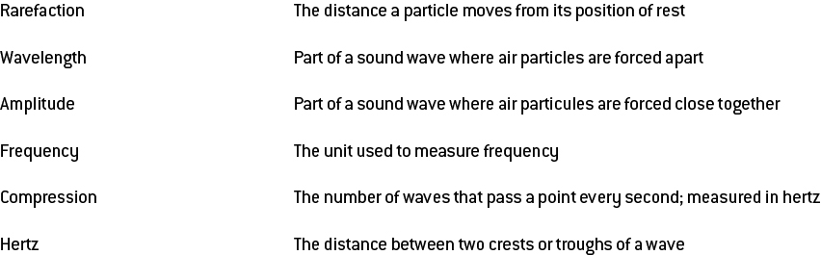

3 On the diagram below, label the areas that represent compressions and rarefactions.

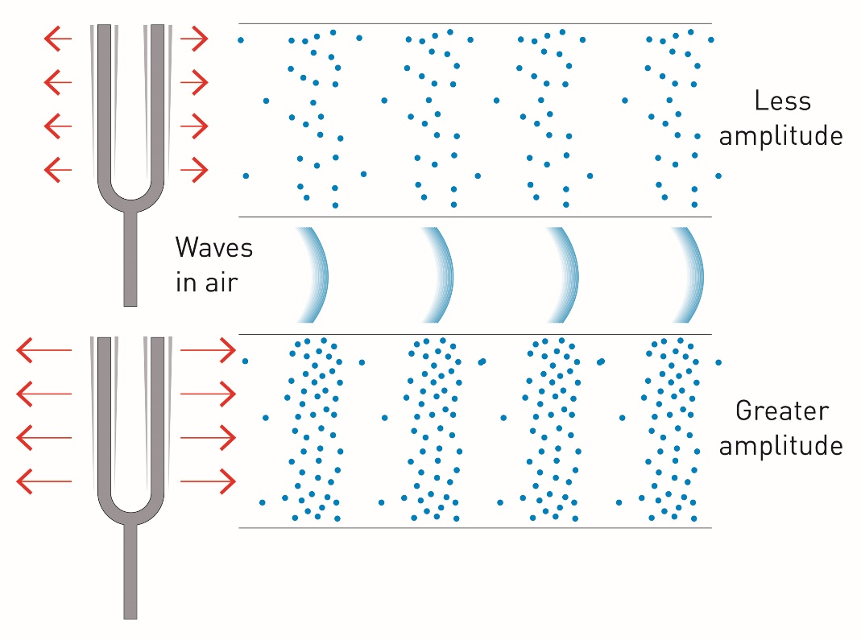

4 If you could see air particles, what would sound look like?

5 Explain how the following are related to frequency, wavelength, compressions and rarefactions.

a high pitch

b low pitch

6 Of the following diagrams, label which would be high pitch, low pitch, high frequency and low frequency.

|  |  |  |  |
| --- | --- | --- | --- |
| a | L:\1. Publishing and Editorial\1. Product\Amazing Science\Amazing Science 9\3. Extras\9. Student worksheets\Artwork\ai for Julia\Edited artwork from Julia\JPEGs\SW0605_01439-r.jpg | b | L:\1. Publishing and Editorial\1. Product\Amazing Science\Amazing Science 9\3. Extras\9. Student worksheets\Artwork\ai for Julia\Edited artwork from Julia\JPEGs\SW0606_01439-r.jpg |
|  |  |  |  |

7 On the above diagrams, indicate where a wavelength would be and which has a greater wavelength.

Extend your understanding

Men and women differ in the pitch of their voices. Conduct research about this phenomenon and answer the following questions.

8 What is the average frequency of male voices?

9 What is the average frequency of female voices?

10 Does a male or female voice have a higher pitch?

11 What is the biological cause of this difference in frequency and therefore pitch between male and female voices?

12 What is 'shimmer'? Explain this concept.

13 Biologically, what happens to a male voice in puberty to make the pitch decrease?

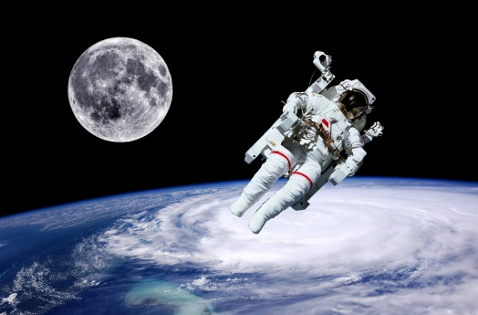Student worksheet

4.2 Sound can travel at different speeds

Pages 72–73 and 194

The speed of sound

1 What is the speed of sound and under what conditions does this occur?

2 Why does the speed of sound vary?

3 What happens to air as it increases in temperature?

4 What does this mean for sound at higher temperatures?

5 What is the relationship between particles and the speed of sound?

6 Does sound travel faster in water or air? Explain why.

7 How fast does sound travel in space? Explain this.

8 On 12 May 2013, Chris Hadfield, on board the International Space Station (ISS), released a music video of his rendition of ‘Space Oddity’ by David Bowie. How was he able to record this in space and have people hear what he was singing?

9 Complete the sentence: The more closely packed the particles in a solid ...

10 In the table below, summarise the speed of sound.

|  |  |  |
| --- | --- | --- |
|  | Causes particles to: | Which means that sound will travel: |
| Increasing temperature |  |  |
| Making something more solid |  |  |

11 Explain how sonar works.

12 Provide 2 applications for sonar.

Extend your understanding

Many daredevils over recent years have dedicated a great deal of time and money to breaking the sound barrier.

13 What is the sound barrier?

14 What happens when you break the sound barrier?

15 Would it be easier to accomplish this in a plane or a car? Explain why.

16 You are travelling very fast in a convertible car and break the sound barrier. You decide to tell this to your best mate sitting beside you. Can your mate hear you? Explain your answer.

17 How fast does a commercial airliner travel? Is this faster or slower than the speed of sound?

18 Can you hear people talk to you when you are on a plane? Explain your answer.

Student worksheet

4.3 Our ears hear sound

Pages 74–75 and 195

The structure and function of the ear

1 Label the structure of the ear.

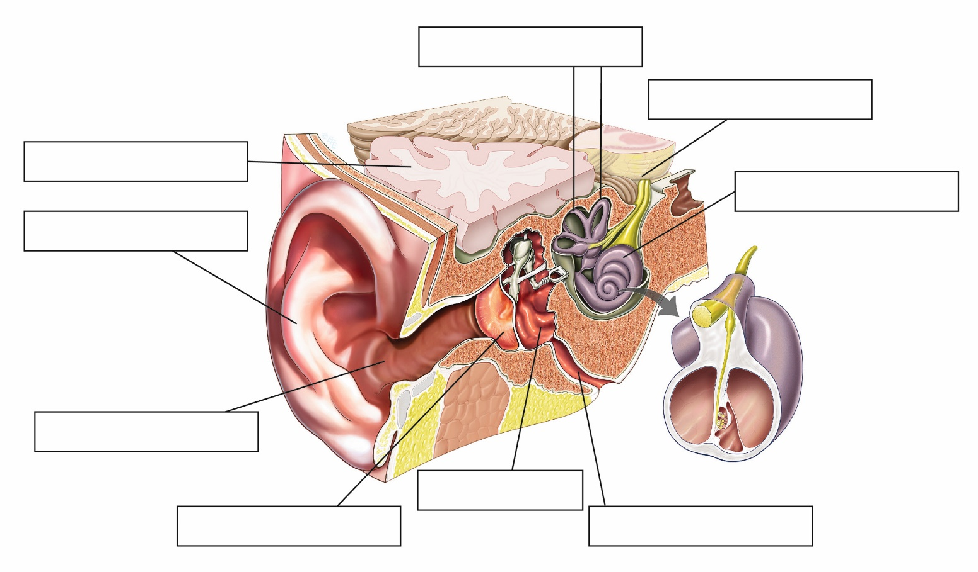

2 State the function of the 3 main parts of the ear and the structures belonging to each part.

a outer ear

b middle ear

c inner ear

3 Match the following structure within the ear to its correct function.

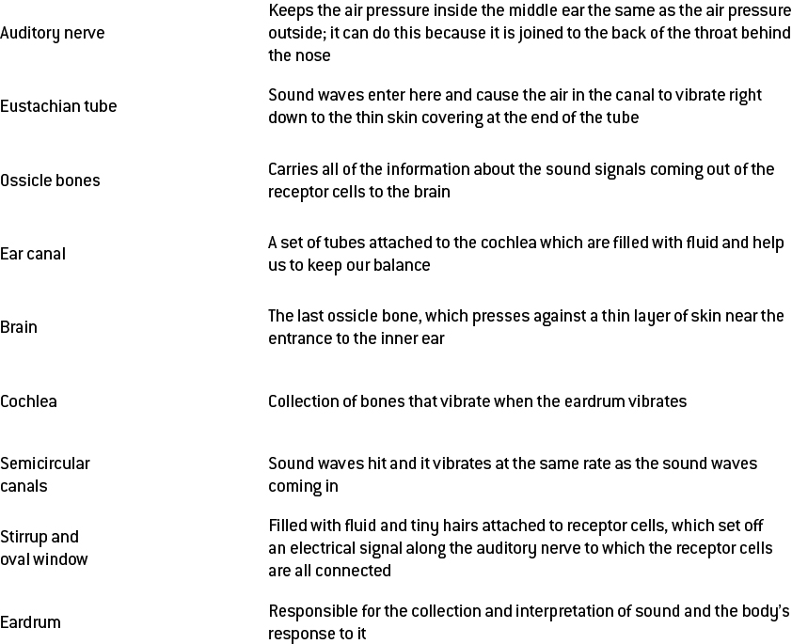

Extend your understanding

4 Using as much of the sound terminology as you have learnt, explain the path that sound waves must follow through the ear and how they are converted into electricity before being transferred to the brain.

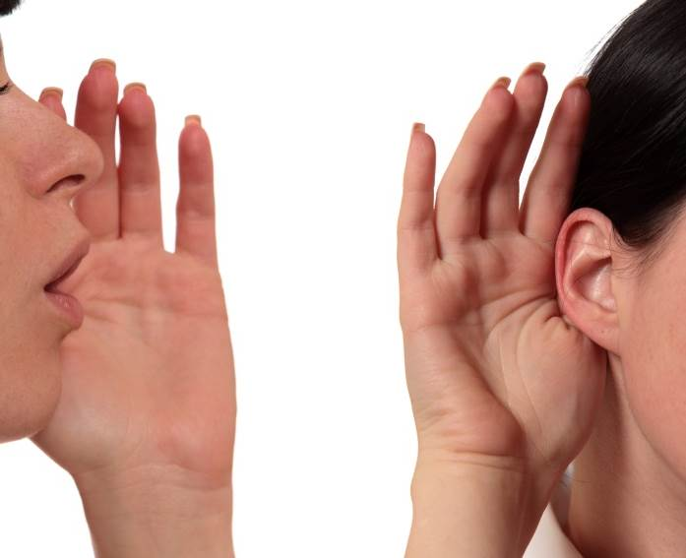Student worksheet

4.4 Things can go wrong with our hearing

Pages 76–77 and 196

Problems with hearing

1 What does hearing rely on?

2 List 3 ways your hearing can become damaged.

3 How can the loudness of sound be measured?

4 What are decibels and what do they measure?

5 What is tinnitus?

6 What causes tinnitus?

7 What damage does this cause to the ear?

8 What is the function of a hearing aid?

9 What is the difference between a hearing aid and a cochlea implant?

10 What is a cochlea implant?

11 What are the 2 sections of a cochlea implant and how do they work?

12 Why do you think that most people choose to have the cochlea implant in one ear, rather than both?

Extend your understanding

13 Choose one of the 3 hearing problems below and answer the following questions.

congenital deafness, conductive hearing loss, sensorineural hearing loss

a In which auditory structure/s does the condition occur?

b What is the cause?

c What effects can it have on your hearing?

d What is the treatment?

e Is there any way to manage the condition/limit ongoing effects?